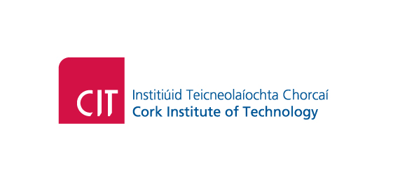

General Data Protection Regulation (GDPR)

Alumni – Privacy Notice

Background
The Institute requires to process and retain personal data relating to you as an alumni or friend of the Institute. The Institute will in compliance with the GDPR respect the confidentiality of your data and implement appropriate technical and organisational measures to prevent unauthorised disclosure.
The Institute is the data controller for all personal data that it holds and processes and is subject to the Data Protection Acts 1998 and 2003 and to the General Data Protection Regulation (GDPR) from 25 May 2018.
The CIT Alumni Office encourages links between alumni and the Institute.

Types of Information Collected
The Alumni Office holds basic records for all alumni including contact details, courses studied, date of birth, nationality and scholarships awarded, which are obtained from your student record when you graduate from the Institute. In addition we also keep a record of communications with you and any other details you provide voluntarily such as employment details or fundraising causes you are interested in.

The following types of personal data may be collected;

- Name, Address, Student Number, DOB, Telephone Number, Email, Educational Details, Business/Professional Details (including contact details).

How we Collect Information

Student Records (Banner), Conferring, First Destinations Survey data and data from those who have updated their details with the CIT Alumni Office. The Institute obtains the personal data it holds about you from a number of sources including the following:

- The Student Records System upon graduation
- The First Destinations Survey
- Directly from you

Purpose of Collecting Information

We will use the details you have given us to communicate and engage with you in relation to the full range of alumni activities and other relevant Institute activities or services including:

- the sending of alumni publications, (Alumni e-newsletter)
- the promotion of benefits and services available to alumni
- notification of, and distribution of information about, events and reunions
- facilitating the establishment of networking groups
- requests to complete relevant surveys
- careers information

Basis for Processing Information

GDPR provides a number of basis on which the Institute can legitimise its processing activities. The Institute processes data in carrying out tasks in the public interest and in the exercise of our official authority and considers the processing of the personal data in this instance is necessary to support its mission of maintaining a strong relationship with alumni and friends.

Sharing Information

We don’t share data internally, however we may send communications on behalf of other Institute Departments.
We do not share your personal data with external parties.
Data storage
The Alumni Office uses a CRM package Raiser’s Edge, which is stored locally.

Data Retention
We will hold your data indefinitely as a member of our Alumni unless you advise us otherwise.

Individuals Rights
Individuals whose personal data and sensitive personal data/special category data is held by the Institute have the following rights regarding their data:
- The right to be informed
- The right to request access to their personal data held by the Institute.
- The right to rectification – to have inaccurate or incomplete personal data rectified.
- The right to erasure of personal data – this will only apply where there is no legitimate reason for the Institute to continue to process the personal data. If you exercise your right to erasure, we will retain a core set of personal data which, for alumni, will include: name, subject(s) studied, graduation details, date of birth and unique identification number so that we do not contact you inadvertently in future, and to maintain your education details for archive purposes. We may also need to retain some financial records about you
- The right to restrict the processing of personal data – individuals have the right to block the processing of their personal data by the Institute in specific situations.
- The right to data portability – students have the right to request provision of some elements of their information (for example academic progress details) in digital form in order to provide it to other organisations.
- The right to object – students can object to the processing of their personal data by the Institute in certain circumstances, including the sending and receipt of direct marketing material.
- The right to object to automated decision making and profiling – individuals have the right to object to decisions taken by automatic means without human intervention in some circumstances.

If you are unhappy with the Institute’s handling of your personal data, or believe that the requirements of the Data Protection Acts or GDPR may not be fully complied with, you should contact the Institute’s Data Protection Officer in the first instance. The Institute’s formal complaint procedure can be invoked if appropriate, and you also have the right to submit a complaint to the Data Protection Commissioner.

CONTACT DETAILS
Carmel Hayes
Data Protection Officer
carmel.hayes@cit.ie
021 4326759

