EUSP-Logo

***The Future   
of our City***

***European Student Parliament Invitation***

***15th, 16th & 17th January 2014 JanJanuJanuaryevent]***

***CIT & City Hall***



Logo Robert Bosch Stiftung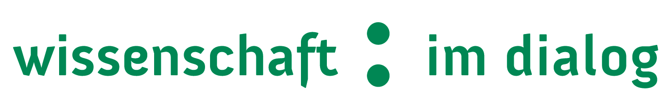EUSP-Logo

European Student Parliaments on Science

Initiated by *Wissenschaft im Dialog* in Berlin, the project “European Student Parliaments” (EUSP) aims at strengthening the dialogue between students aged 15 to 19 and science research throughout Europe. Over a period of three days the students will become acquainted with parliamentary decision-making processes in simulated parliaments. They will work on different aspects of the topic “The future of our city” and will prepare the final parliamentary debate in working groups and expert hearings. Approximately 2000 students from across Europe will participate in 20 national parliaments. 100 of them will have the opportunity to take part in a final European student parliament, which will take place during the EuroScience Open Forum conference 2014 in Copenhagen. The project is funded by the Robert Bosch Foundation. **www.student-parliaments.eu**

Cork Institute of Technology

Bishopstown,

Co. Cork

www.cit.ie

Please go to the following website for any additional information

[**www.student-parliaments.eu**](www.student-parliaments.eu)

**Cork Institute of Technology**

[*Cork Institute of Technology*](http://www.cit.ie)traces its roots back to the 1830’s and today it is a vibrant institution with 15,000 students covering all the major disciplines from science and engineering to business, humanities and the creative arts. CIT’s research focuses on finding solutions to major issues faced by society and includes world-leading expertise in developing Smart Cities

[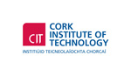](http://www.cit.ie/contentfiles/images/Logos/CIT_large/CIT%20MAIN%202012%20(RGB)1.jpg) logo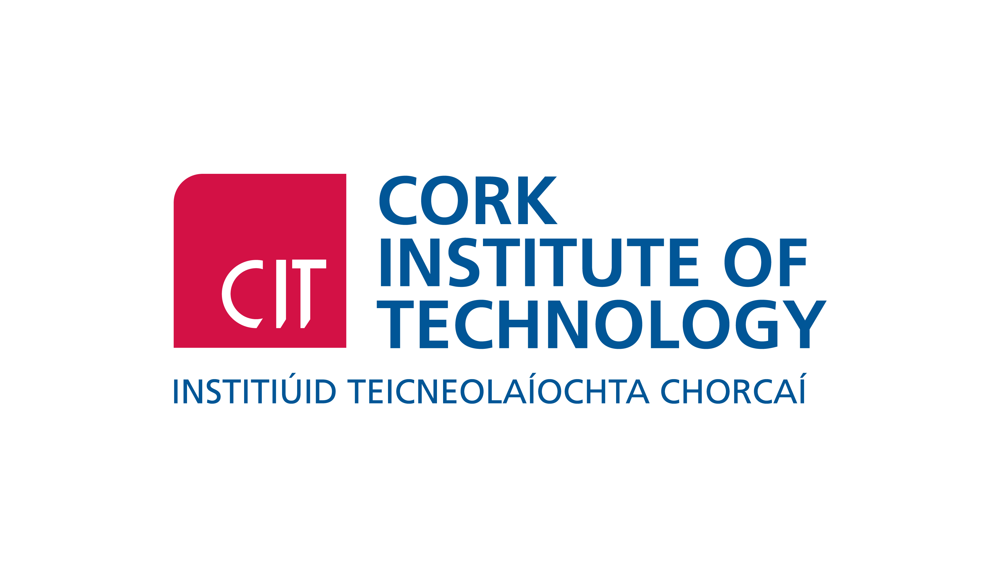]

Preparation and topics

The theme of the Parliament is “The future of our City” and the topics discussed will be:

* Future mobility – New approaches in the city
* City. Climate. Change
* Resources in the city: sky-farming & urban gardening
* Energy efficient houses and flats
* Smart city: life in an urban network

Student parliament

The European Student Parliament will take place from Wednesday 15th January to Friday 17th January 2014 in the City Hall and in CIT. Over the course of three days, students will work on solution statements for each subtopic in 5 working groups and in an activity-oriented approach.

Results

The students’ position papers and results will be summarised and uploaded to the project website *www.student-parliaments.eu* in the aftermath of the student parliament. In addition, their results will serve as the basis for the final European Student Parliament in Copenhagen and, thus, will be discussed by students from across Europe.

Funded by:

Organised by:

A project by:

**INVITATION**

**Cork Institute of Technology** in conjunction with *Wissenschaft im Dialog* will host the **European Student Parliament** in **CIT** andthe **City Hall** on the 15th, 16th and 17th January 2014. In working groups and through the exchange with scientists, secondary school students aged between 16 and 18 years from 19 schools will discuss current issues on the topic “The future of our city” and will prepare and conduct a concluding parliamentary debate.

Students will have the opportunity to discuss topics relevant to the future with students from across Cork City and County. Five of the students will additionally have the chance to exchange their ideas on a European scale with 95 students from across Europe in the ***final European Student Parliament*** in **Copenhagen** in **June 2014**.

European Student Parliament

**The Future of our City**